LOOKING GLASS METADATA SCHEMA EXPLORER
USER GUIDE
DATE: December 2025
Developed by:
GMU - DAEN 690 – Team TrendSetters

Contents
1. Introduction 4
2. Using the Explorer 5
2.1. Launching the Application 6
2.2. Schema’s Tables & Columns Sidebar Panel: 7
2.3. Main Schema Graph Exploration 10
2.4. Selected Table Graph Exploration 13
2.5. Execute SQL Query and Query’s Result 15
2.6. Record Graph – Flow Graph Exploration 16
2.7. Record Graph - Data Lineage Graph Exploration 18
2.8. Search Records by Keyword 20
3. Troubleshooting 21
ANNEX A: Code Summary 22
Summary of index.html 22
Summary of main.js 25
Summary of graph.js 28
Summary of api.js 39
Summary of results.js 42
Summary of server.js 45
Summary of cytoscape-helpers.js 49
Summary of sidebar.js 51
Summary of tooltips.js 53

Figure 1: UI Files Structure 5
Figure 2: LookingGlassMetadata Schema UI 7
Figure 3: Sidebar Search for "node_id" 8
Figure 4: Main Schema Graph 9
Figure 5: Tables and Columns Color-Coded Scheme 10
Figure 6: Selected Table Graph of 'data_object' Table 11
Figure 7: Selected Table Graph 12
Figure 8: Execute SQL Query and Query's Result Containers 14
Figure 9: Flow Grap 15
Figure 10: Data Lineage Graph 17
Figure 11: Query's Result of "table_attribute" Table 18
Figure 12: Search Records by Keyword 19

Introduction
The Looking Glass Metadata Schema Explorer is an interactive web-based tool for visualizing database schema relationships and record-level data flows. It helps analysts, engineers, and data stewards understand how datasets, tables, and records are interconnected.
Key Features
- Visualize schema relationships between tables using interactive graphs.
- Explore record-level connections through upstream and downstream expansions.
- Filter, search, and highlight records dynamically.
- Export visualizations such as PNG, JPG, or SVG.
- Access contextual actions through right-click menus.
System Components
- Presentation Layer (Frontend):
These files together form the browser-based client that requests data from the backend and renders interactive schema graphs and query results.
  - index.html → Entry point (HTML shell).
  - main.js → Orchestrates the app.
  - script.js → General UI logic.
  - graph.js → Builds schema graphs using Cytoscape.js.
  - cytoscape-helpers.js → Utility functions for Cytoscape (disable right-click, export as image, etc.).
  - tooltips.js → Tooltip display for nodes/edges.
  - results.js → Displays query results (e.g., top rows, joins).
  - sidebar.js → Sidebar UI, filters, checkboxes, hide/unhide logic.
  - api.js → Handles AJAX calls (fetchTopRows, fetchJoins, etc.).
- Application Layer (Backend / API) server.js (Express):
This layer is the bridge between the frontend and database. It converts client requests into SQL queries and sends JSON results back, hosts static files (index.html + JS), provides REST API endpoints, and uses pg (node-postgres) connection pool for PostgreSQL.
- Data Layer:
Stores tables, metadata, relationships, and data using PostgreSQL database (Looking Glass Metadata schema). pgAdmin is an external DB UI for admin/maintenance).

Using the Explorer
The explorer comprises of an index.html and javascript files (js files) as mentioned in section 1. The files structure is as depicted in the below picture.
project/
server.js
Public/
api.js
cytoscape-helpers.js
graph.js
index.html
main.js
results.js
sidebar.js
tooltips.js
package
Figure 1: UI Files Structure

Launching the Application
Step 1: Create a directory named LookingGlassMetadataSchemaExplorer.
Step 2: Copy the folder project.zip file, which can be downloaded at this GitHub link: https://github.com/ansarisam/trendsetters.git, into the created directory and unzip the file.
Step 3: Install pgAdmin and PostgreSQL and node user and password. These can be downloaded at https://www.pgadmin.org/download/pgadmin-4-windows/.
Step 4: Install Visual Studio IDE. It can be downloaded at https://visualstudio.microsoft.com/.
Step 5: Restore the LookingGlassMetadata schema from provided LookingGlassDump.sql file and note the database name.
Step 6: Open server.js in Visual Studio IDE and modify the below code to reflect user, database, and password as set up in step 3 and 4:
// PostgreSQL connection
const pool = new Pool({
user: 'postgres',
host: 'localhost',
database: 'Database Name',
password: 'password',
port: 5432,
});
Step 7: Open a window command prompt and enter the following commands:
“npm init -y” without quotation marks and hit enter.
“npm install pg” without quotation marks and hit enter.
“npm install express” without quotation marks and hit enter.
Step 8: In the “TERMINAL” tap of the Visual Studio IDE, navigate to directory of the saved project, then type in the below command:
“node server.js” without quotation marks and hit enter.

You should see:
“Server running on http://localhost:3000”

Put the mouse cursor on the link and click on “Follow Link (ctrl + click)” link to open the UI in a browser. You should see a similar UI like below:
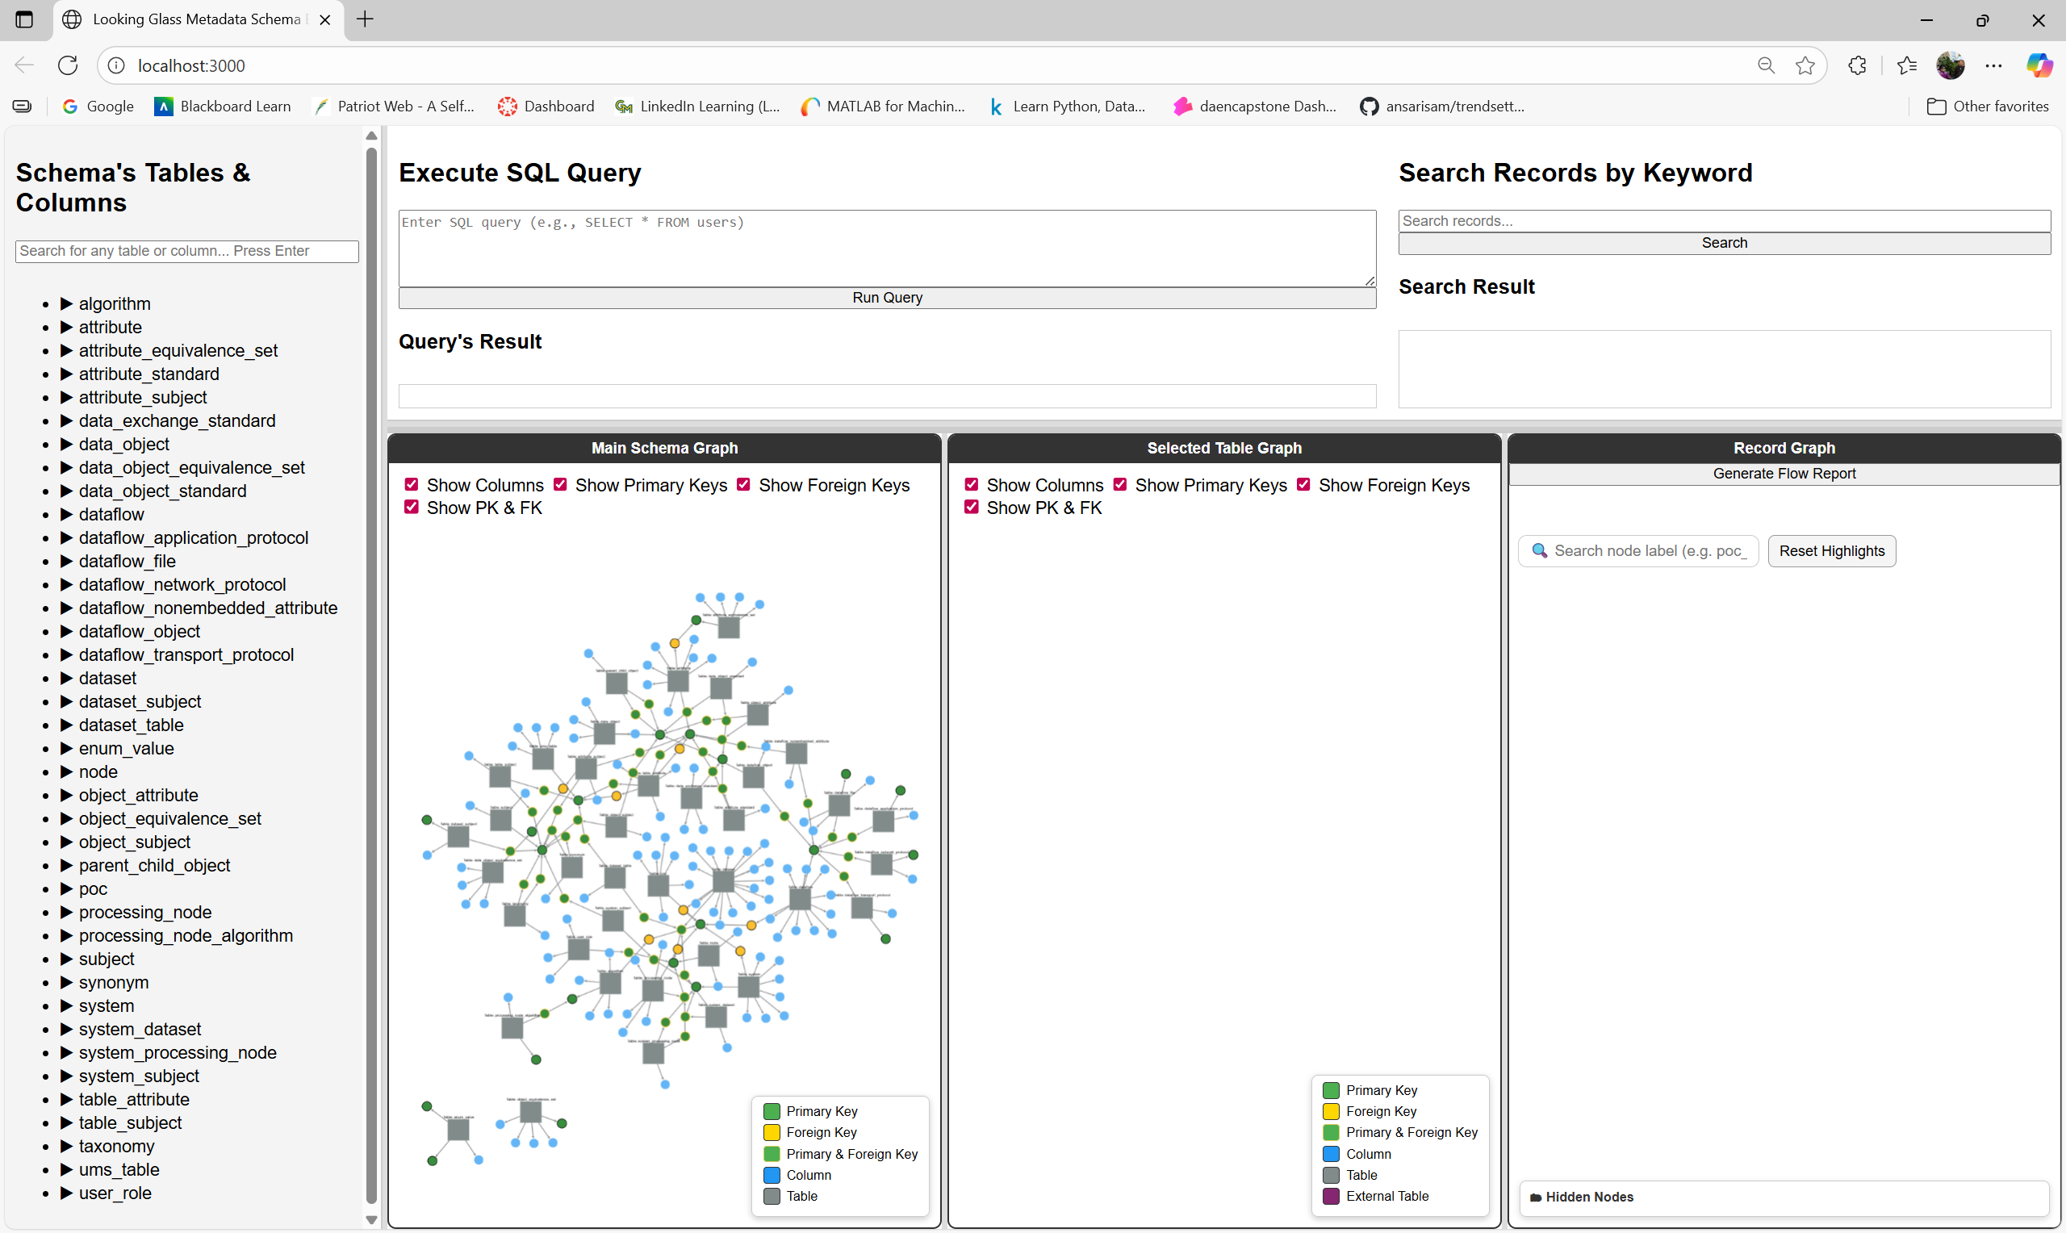
Figure 2: LookingGlassMetadata Schema UI

Schema’s Tables & Columns Sidebar Panel:
The sidebar panel is a tree-like navigation list of database tables and their columns. It connects to the Main Schema Graph (the left-most graph container). It acts as a metadata navigator, allowing users to:
- Browse all tables and their columns
- Expand/collapse tables:
  - Clicking the triangle toggles visibility of the table’s columns.
  - Clicking a column highlights that specific column node in the Main Schema Graph.
  - It also centers the Main Schema Graph view on that table/column node.
- Search for entities by name. It:
  - Filters tables/columns that match the query,
  - Rerenders the sidebar with only matching items,
  - Highlights corresponding nodes in the Main Schema Graph,
  - Scrolls to the first match.
Interaction: Right-Clicks (Context Menus):
- Right-click Table Node (cxttap):
  - Shows a custom context menu (your own small popup menu):
    - Generate SELECT * Query
    - Generate SELECT with JOINs
  - The clicked menu generates query’s result displayed in the Query’s Result table and a query statement displayed in the Execute SQL Query box.
Example, searching for node_id in the search bar will filter the tables/columns list and highlight all matched columns with light yellow as in the below snapshot.
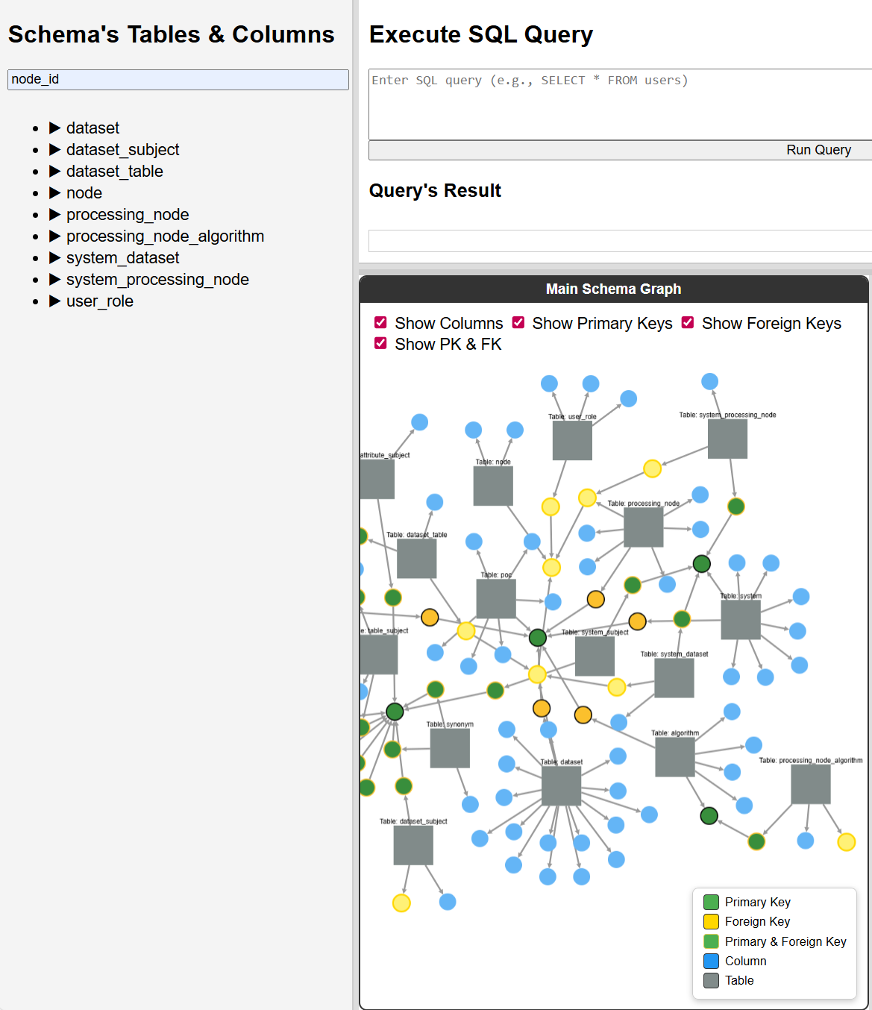
Figure 3: Sidebar Search for "node_id"

Main Schema Graph Exploration
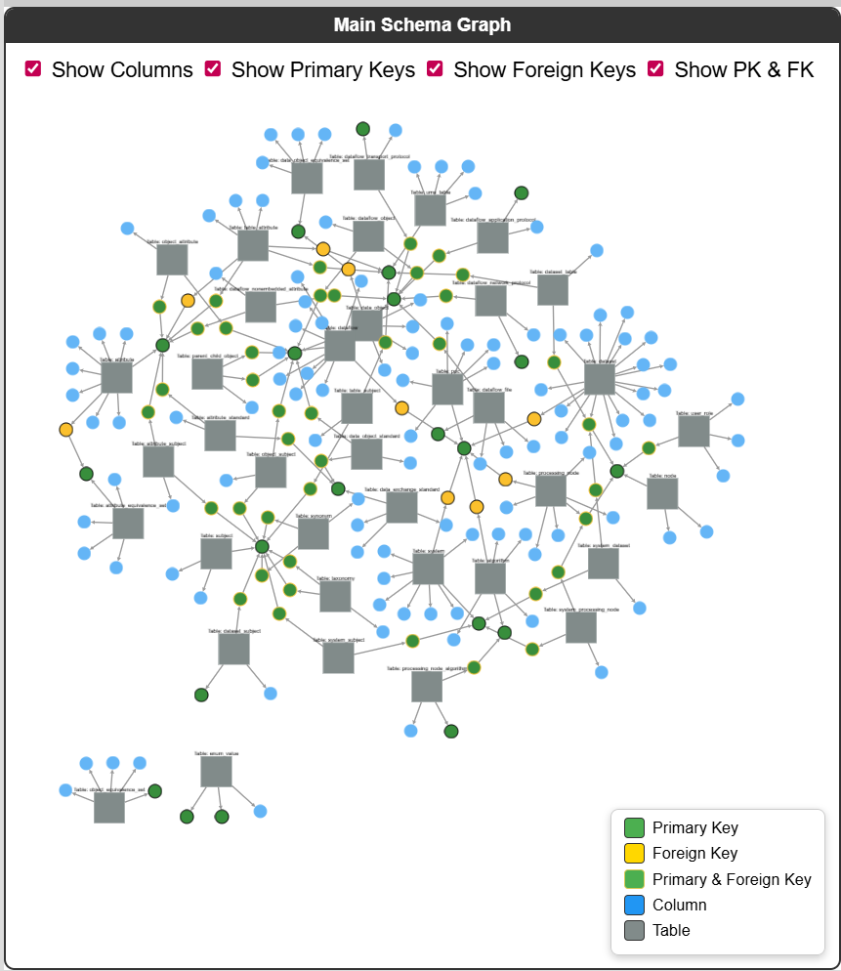
Figure 4: Main Schema Graph
Graph Initiation:
- The Main Schema Graph is generated when the UI is first opened using the Looking Glass Metadata schema describing tables, columns, and foreign key relationships. The graph contains:
  - Tables as rectangle nodes.
  - Columns as ellipse nodes.
  - Edges of relationships table column (a table has column) and column column (foreign key link).

- Tables and columns are color-coded as described in the below table:

Type | Shape | Color
Table | Rectangle | Gray
Column | Ellipse | Blue
PK | Ellipse | Green (border black)
FK | Ellipse | Yellow (border black)
PK+FK | Ellipse | Green + yellow border
Figure 5: Tables and Columns Color-Coded Scheme
Style & Behavior:
- The checkboxes show/hide column node types interactively.
Tooltips:
- Tooltips are attached to nodes and edges to show additional information when the mouse cursor is hovered over the nodes/edges.
Interaction: Left-Clicks:
- When left-clicked, table node opens a detailed subgraph in the Selected Table Graph container (the middle graph box).
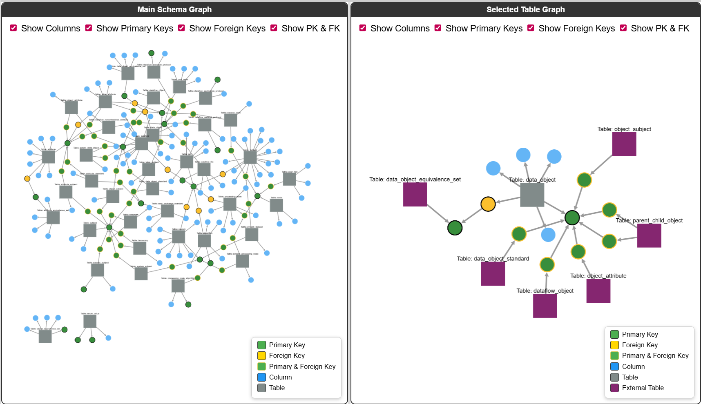
Figure 6: Selected Table Graph of 'data_object' Table
Interaction: Right-Clicks (Context Menus):
- Right-click Table Node (cxttap):
  - Shows a custom context menu (your own small popup menu):
    - Generate SELECT * Query
    - Generate SELECT with JOINs
  - The clicked menu generates query’s result displayed in the Query’s Result table and a query statement displayed in the Execute SQL Query box.
- Right-click Background:
  - Shows options to export the current graph as PNG, JPG, or SVG.

Selected Table Graph Exploration
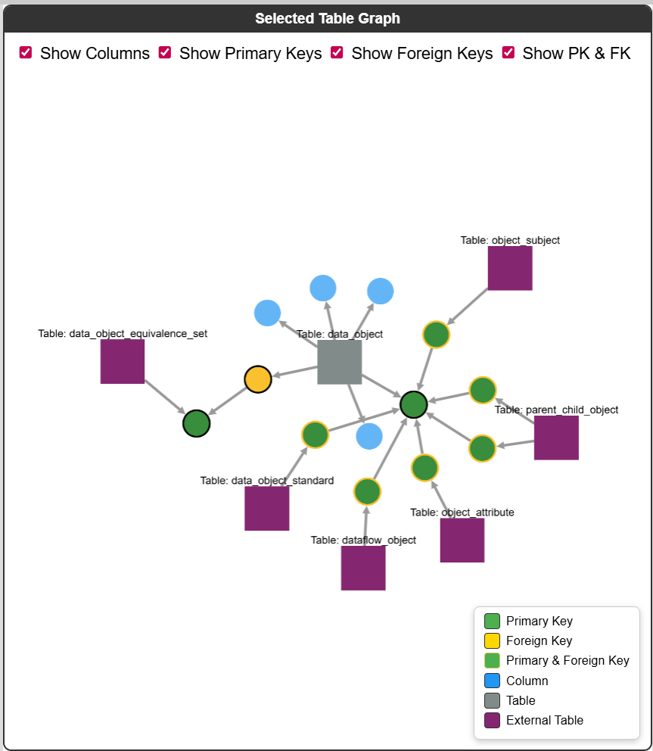
Figure 7: Selected Table Graph
Graph Initiation:
- A Selected Table Graph is generated when a table node in the Main Schema Graph is clicked on. This focused subgraph shows:
  - The clicked table itself.
  - Its columns (PKs, FKs, etc.)
  - Related external tables connected via foreign keys.
Style & Behavior:
- The checkboxes show/hide column node types interactively.
Tooltips:
- Tooltips are attached to nodes and edges to show additional information when the mouse cursor is hovered over the nodes/edges.
Interaction: Right-Clicks (Context Menus):
- Right-click Table Node (cxttap):
  - Shows a custom context menu (small popup menu):
    - Generate SELECT * Query
    - Generate SELECT with JOINs
  - The clicked menu generates query’s result displayed in the Query’s Result table and a query statement displayed in the Execute SQL Query box.
- Right-click Background:
  - Shows options to export the current graph as PNG, JPG, or SVG.
Interaction: Left-Clicks:
- Left-click on external table (purple rectangle):
  - The table is expanded into a full table with its columns.

Execute SQL Query and Query’s Result
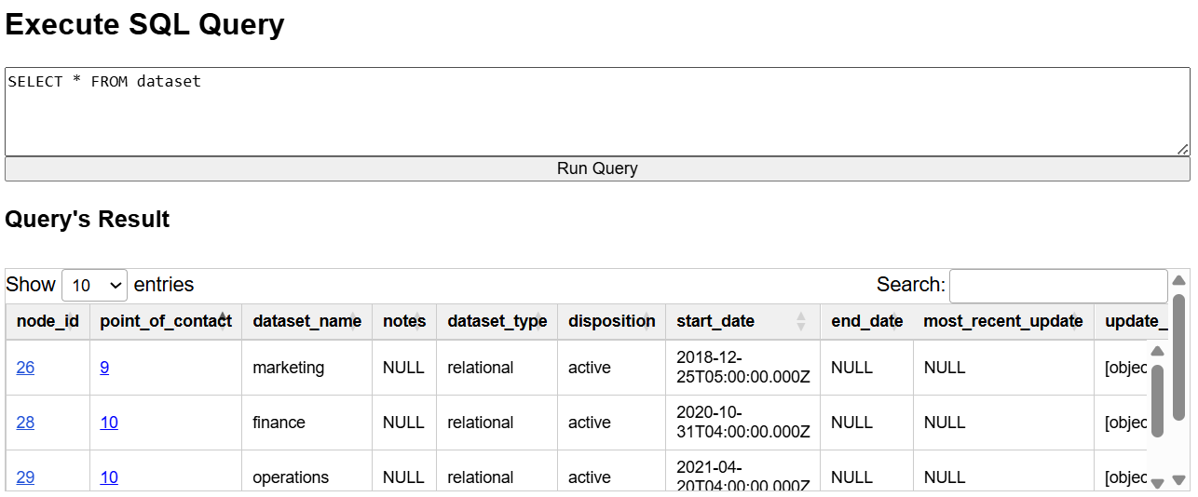
Figure 8: Execute SQL Query and Query's Result Containers
The Execute SQL Query:
The Execute SQL Query container allows user to type a SQL query and run it by clicking on the Run Query button. The result appears inside the Query’s Result container as a table.

The Query’s Result:
The Query’s Result container bridges SQL query results from the backend into an interactive HTML table. SQL query results are generated when the context menus “Generate SELECT * Query” / “Generate SELECT with JOINs” is clicked. The table:

- Reorders columns to show PKs/FKs first.
- Attaches interactive logic:
  - Clicking node_id builds a dataflow graph.
  - Clicking PK/FK cells builds a record-level data lineage graph.
- Applies table sorting, filtering, and scrolling.
- Shows an error message if nothing usable is returned.

Record Graph – Flow Graph Exploration
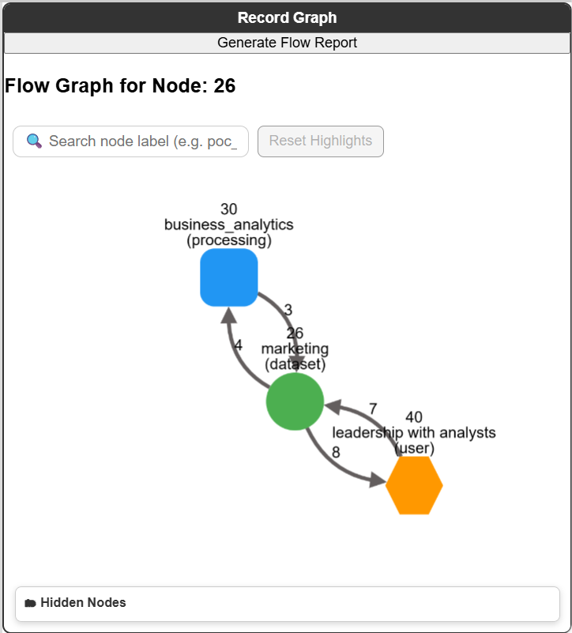
Figure 9: Flow Grap
Graph Initiation:
- Flow graphs are generated using dataflow records of the “dataflow” table.
- A flow graph can be initiated by clicking on any node_id record in any table such as node_id 26, 27, 28, etc. of table “dataset” in Figure 7.
- The generated graph includes:
  - The clicked node and its immediate related nodes: a node can be a dataset, processing, or user
  - Edges are connectors between source nodes and destination nodes to represent dataflows.
Tooltips:
- Tooltips are attached to nodes and edges to show additional information when the mouse cursor is hovered over the nodes/edges.
Interaction: Right-Clicks:
- Right-Click on Nodes:
  - Hides nodes and their edges
  - Adds them to the list at the bottom of the container, where clicking on nodes restores them.
- Right-click Background:
  - Shows options to export the current graph as PNG, JPG, or SVG.
Interaction: Left-Clicks:
- Left-click on Nodes:
  - Gets new flows connected to the nodes.
  - Adds new nodes and edges to the current graph dynamically.
Generate Flow Report:
- When clicking on the “Generate Flow Report” button in the container:
  - Information of all visible nodes and edges from displayed graph are compiled into a report.
  - A popup window inside the browser is generated to display the report.
  - “Save” option is available for saving the report.

Record Graph - Data Lineage Graph Exploration
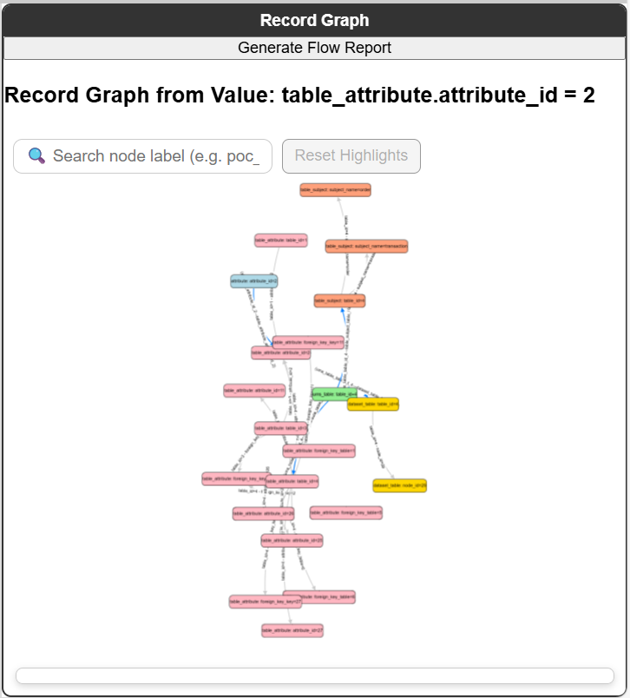
Figure 10: Data Lineage Graph
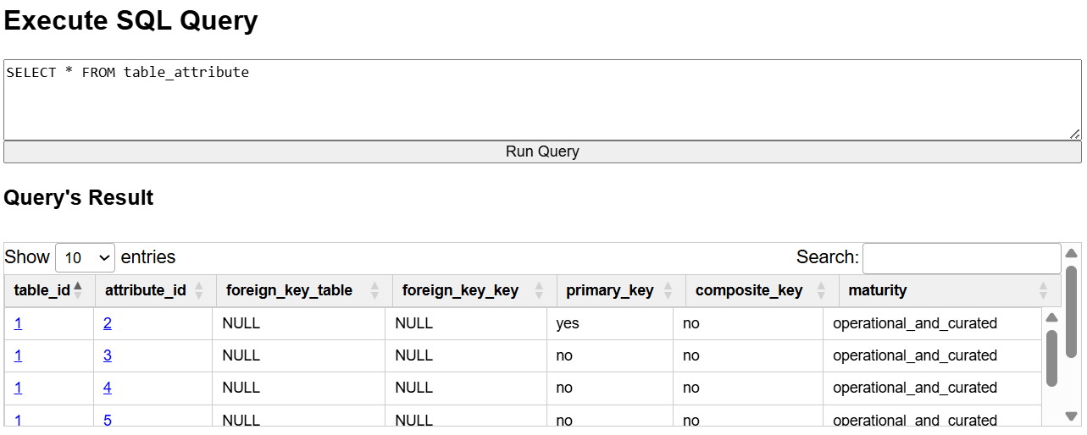
Figure 11: Query's Result of "table_attribute" Table
Graph Initiation:
- A flow graph can be initiated by clicking on any PK/FK record in any table such as table_id 1 or attribute_id 2, 3, etc. of table “table_attribute” in Figure 10.
- The generated graph includes:
  - The clicked node and its immediate related nodes.
  - Edges are connectors between source nodes and destination nodes to represent the flow of the record.
Tooltips:
- Tooltips are attached to nodes and edges to show additional information when the mouse cursor is hovered over the nodes/edges.
Interaction: Right-Clicks:
- Right-Click on Nodes:
  - Expansion menu appears for upstream and downstream expansion of the node.
  - Available upstream/downstream nodes are added to the graph when a menu option is selected.
- Right-click Background:
  - Shows options to export the current graph as PNG, JPG, or SVG.
Interaction: Search for a specific keyword
- Keyword search inside the container:
  - Highlights matched nodes and edges.
- Reset the graph:
  - Restores original colors of all nodes.
Generate Flow Report:
- When clicking on the “Generate Flow Report” button in the container:
  - Information of all visible nodes and edges from displayed graph are compiled into a report.
  - A popup window inside the browser is generated to display the report.
  - “Save” option is available for saving the report.

Search Records by Keyword
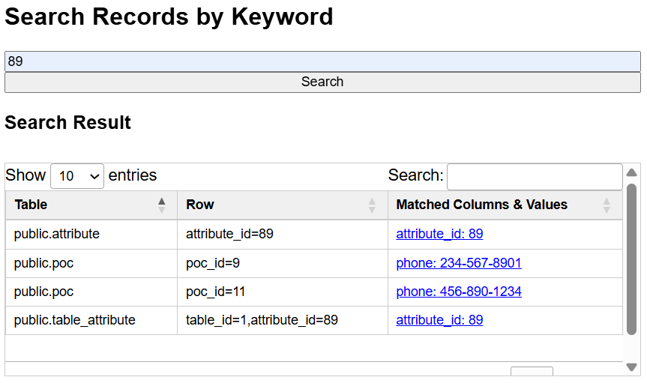
Figure 12: Search Records by Keyword
Search Records by Keyword allows users to search for a value name and display matches in an interactive, sortable, searchable table. The result is connected to main schema graph for further analysis.
Clickable Columns (Integration with Graphs):
- When click on a matched column & value:
  - Highlights the corresponding column node in the Main Schema Graph.

Troubleshooting
Issue | Cause | Solution
Graph doesn’t display | Backend query failed | Check PostgreSQL connection in server.js for correct connection information.  const pool = new Pool({  user: 'postgres',  host: 'localhost',  database: 'Database Name',  password: 'password',  port: 5432,  });

ANNEX A: Code Summary

Summary of index.html
The index.html file defines the full UI structure, layout, styles, and external libraries needed for the web-based metadata explorer. It provides the container framework in which all interactive features—graphs, tables, tooltips, and search—are rendered.
1. Imported Libraries
The file loads all required frontend libraries:
- Cytoscape.js for graph visualization
- Cytoscape plugins
  - Context menus
  - COSE-Bilkent layout
- jQuery and DataTables for interactive query/search result tables

2. Global Layout
The UI is divided into three major regions:
Sidebar
- Displays schema tables and columns
- Contains search bar
- Can be resized via a draggable divider

Query Panel
Contains two parallel tools:
- SQL Query Executor
  - Text area for entering SQL
  - Button to run the query
  - Results table displayed under it
- Keyword Record Search
  - Keyword input and search button
  - Results displayed in another DataTable
Both areas are scrollable and take up ~40% of the vertical space.

Graph Area
The bottom portion contains three side-by-side graph views, separated by draggable dividers:
- Main Schema Graph
  - Entire schema with tables, columns, PK/FK relationships
  - Toggle controls for visibility of columns, PKs, FKs
  - Legend explaining node colors
  - Resizable container
- Selected Table Graph
  - Focused view of a single table and its immediate FK/PK neighbors
  - Similar toggle controls and legend
  - Shows whether items are external references
- Record Graph
  - Shows record-level relationships from query results
  - Contains controls for search and highlight reset
  - Hidden nodes list and expand controls
  - Button for generating flow report
All three graph containers are built for Cytoscape.

3. Styling & Visual Behavior
The embedded CSS styles control:
- Flexible, responsive three-panel layout
- Resizable dividers (horizontal and vertical)
- Sticky table headers
- Floating controls and node info panels
- Sidebar collapsible columns
- Graph legends and hidden-node panels
- Typography and spacing consistency

4. App Initialization
At the bottom, the file loads:
<script type="module" src="/public/main.js"></script>
This launches the main orchestrator script, which activates event handlers, queries the backend, and renders Cytoscape graphs.

Summary of main.js
The main.js file serves as the central controller of the Looking Glass Metadata Explorer frontend. It initializes the application, binds UI event handlers, and manages all resizing behaviors for the sidebar, query panel, and graph area.

1. Application Initialization & Event Binding
main.js imports backend API functions and graph instances:
- submitQuery – executes SQL
- searchRecords – runs keyword search
- fetchAndBuildSchema – loads schema and builds the main graph
- generateFlowReport – produces flow reports from record graphs
- cy / cyTable – Cytoscape graph instances
It wires the main UI buttons:
- Run SQL Query
- Search Records
- Generate Flow Report
On page load (DOMContentLoaded), it automatically loads and renders the schema graph.

2. Sidebar Resizing (Vertical Split)
The script enables drag-to-resize for the left sidebar:
- Tracks dragging state (isResizingSidebar)
- Dynamically changes sidebar width within min/max bounds
- Automatically calls cy.resize() and cyTable.resize() to keep graphs reacting to layout changes

3. Query Panel Resizing (Horizontal Split)
A horizontal divider is inserted between:
- Query Panel (top)
- Graph Area (bottom)
Users can drag this divider to change how much vertical space the query area occupies.
The drag updates:
- Query panel height
- Graph layouts (via Cytoscape resize events)

4. Three-Graph Vertical Resizing (Main • Table • Record)
Two vertical dividers (divider1, divider2) allow the user to resize:
| Main Graph | Table Graph | Record Graph |
The makeVerticalDividerAll() function handles:
- Drag tracking (isDragging)
- Preserving min widths
- Synchronized resizing of all graph containers
- Cytoscape resize updates
This section enables a fully adjustable three-panel graph workspace.

5. Automatic Window-Sized Layout Adjustments
The script dynamically resizes the graph area based on:
- Window height
- Header height
- Query panel height
This ensures the graph area always fills the remaining space.
Listeners:
- window.resize
- window.load
The function adjusts the container height and resizes all active Cytoscape graphs.

Summary of graph.js
The graph.js module is responsible for all graph construction, rendering, interaction logic, and sub-graph generation in the Looking Glass Metadata Explorer. The module also integrates tooltips, context menus, UI filters, and graph exporting.

1. buildGraph(data) — Build the Main Schema Graph
Responsible for generating the global database schema visualization.
Responsibilities
- Parse the raw schema rows returned from the backend.
- Create:
  - Table nodes (rectangles)
  - Column nodes (ellipses)
  - Table → Column edges
  - Foreign-key edges
- Apply class styling for:
  - PK, FK, PK+FK
  - Display filters (column toggle, pk toggle, etc.)
- Initialize Cytoscape instance in the main view.
- Attach:
  - Tooltip handlers
  - Right-click context menus
  - Auto-fit, zoom restrictions
  - Left-click navigation into detail views (table graph / column graph)
Output
- Returns the list of table names.
- Stores schema globally (schemaData) for downstream table expansion.

2. buildTableGraph(tableName, details, addExternalNodes = true) — Detailed Table View
Creates a focused graph for one table, showing:
- All columns
- PK/FK indicators
- Immediate foreign-key relationships
- Optional expansion into referenced tables
Responsibilities
- Render a new Cytoscape graph inside the table view panel.
- Add:
  - The selected table as the root node
  - All its columns
  - PK/FK edges
  - External referenced tables (optional)
- Add visibility filters (column, pk, fk)
- Add right-click export options (save PNG/JPG/SVG)
- Attach lineage expansion:
  - Immediate FK neighbors
  - Expand external tables into full tables on click
Behavior
The table graph becomes an interactive, expandable metadata lens that lets users explore relationships in depth.

3. expandTableInGraph(tableId, cyTable, details) — Expand an External Table Node
This function upgrades a previously "external" placeholder node into a fully expanded table node.
Responsibilities
- Replace the placeholder node with a full table node.
- Add all its columns.
- Add PK/FK edges.
- Add its own external FK neighbors.
- Re-run layout for smooth expansion.
Purpose
Supports progressive exploration without overwhelming the user.

4. buildColumnGraph(colData) — Focus View for a Single Column
Creates a mini-graph centered on one column, showing:
- Its parent table
- FK relationships (upstream/downstream)
- Connected tables and columns
Purpose
Column graph provides a zoomed-in lineage perspective, useful for:
- Impact analysis
- Understanding a column’s role in multiple joins
- Debugging ETL relationships
5. addPKColumnsForExternal() — Add PK Nodes for External Tables
Purpose
Ensures that when an external table (a table referenced by FK but not fully expanded) is displayed in a graph, its primary key columns are still shown so relationships make sense.
What it does
- Looks up PK columns for the target table in schemaData.
- If no PKs are defined and a fallback FK is provided, creates a synthetic PK node.
- Adds missing PK column nodes to the graph.
- Creates the table → PK "has_column" edges.
- Tracks edges to avoid duplicates.
Role
Supports progressive graph expansion by ensuring external tables remain meaningful.

6. showMenu() — Context Menu System
Purpose
Provides a lightweight, custom right-click menu for export and utility operations.
What it does
- Creates a popup menu at screen coordinates.
- Populates menu items from the caller's options array.
- Binds click actions for each menu item.
- Removes existing menus and closes when user clicks outside.
Role
Enables consistent UI interactions across all graphs (e.g., Save as PNG/JPG/SVG).

7. buildRecordGraph() — Build Row-Level or Flow-Level Graphs
Purpose
Renders a record-level visualization of a table.
Supports both:
- Flow graphs (source → destination edges),
- Node graphs (PK/FK value relationships within rows).
Flow Mode (tableType = "flow")
What it does
- Creates nodes representing systems or endpoints (source & destination).
- Adds edges representing a dataflow (ETL metadata, bandwidth, encryption, etc.).
- Builds specialized flow-type filters (future extensions).
- Labels nodes with ID, name, and type.
Node Mode (tableType = "node")
What it does
- Extracts only PK/FK columns from each row.
- Creates record nodes for unique PK/FK values.
- Creates edges between PK/FK values within the same row (implied relationships).
- Builds FK-based filter controls that dynamically hide/show related edges.
- Maintains visibility synchronization (nodes hide when all their edges are filtered).
Shared Behaviors
- Clears previous graph and resets UI elements.
- Creates Cytoscape instance with custom styling.
- Adds interactive instruction overlay.
- Enables node hiding and un-hiding with UI list management.
- Attaches tooltips and right-click export menu.
- Sets up click behavior (tap to hide nodes).
- Manages “hidden” and “filtered-out” classes.
Role
Provides a flexible, expressive way to visualize:
- Individual record relationships,
- Metadata flows,
- Join tables,
- PK/FK-based row clusters.

8. classifyTableByRows() — Flow vs Node Table Detection
Purpose
Automatically determines whether the records should be displayed as:
- A flow graph, or
- A node graph.
What it checks
- If the row contains source_id and destination_id → flow table.
- If exactly two foreign-key-looking columns exist → join-like node table.
- Otherwise defaults to node mode.
Role
Allows backend-agnostic auto-configuration of record graph visualization.

9. highlightAttributeNodeInMainGraph() — Highlight Column in Main Schema Graph
Purpose
Visually locate and emphasize a specific column or attribute node in the main schema graph.
What it does
- Finds the node by ID in the global graph.
- Clears previous highlights and applies new selection styling.
- Centers and zooms the main graph viewport on the highlighted node.
- Animates fit/zoom for user clarity.
Role
Supports cross-view coordination —
e.g., selecting a column in a record/table graph highlights it in the schema graph.
10. traceColumnLineage(table, pkValue, columns)
Purpose:
Highlights the lineage of a specific record in the main schema graph (PK/FK column-level graph).
What it does:
- Resets all previous highlights.
- Determines which columns represent the selected record:
  - Either the provided columns, or all columns in that table.
- Highlights:
  - The record’s columns (highlight-record)
  - The table node itself (highlight-table)
- Traverses and highlights lineage:
  - Upstream: FK → referenced PK
  - Downstream: PK → referencing FK
- Uses classes:
  - highlight-upstream, highlight-downstream, highlight-record
- Fits the view to the set of highlighted nodes.
Result:
A visual trace of where a record’s data comes from and where it flows to based on PK/FK structure.

11. buildFlowGraph(data, centerNodeId)
Purpose:
Builds an ETL/dataflow graph showing how datasets, processes, and users flow data between each other.
What it does:
- Fully resets previous flow/record graphs.
- Clears UI controls (search, filters).
- Displays title for the flow graph.
- Converts flow records into Cytoscape:
  - Nodes = datasets, processing nodes, users, etc.
  - Edges = ETL dataflows between nodes.
- Applies styling:
  - Node types (dataset, processing, user)
  - Dataflow edges
  - Highlight for the selected center node
- Adds interaction features:
  - Tooltip support
  - Right-click background = save as PNG/JPG/SVG
  - Auto-fit to center node
  - Click node to expand more flow graph (loads more data from backend)
  - Right-click node to hide/unhide
  - Maintains a dynamic list of hidden nodes
Result:
A dynamic, explorable dataflow graph where the user can progressively expand nodes to see the entire ETL lineage.

12. buildRecordGraphFromValue(table, column, value)
Purpose:
Builds a record-level graph (PK/FK instance-level flow) showing parent/child records linked by foreign keys.
What it does:
- Resets previous graphs & UI components.
- Updates the title to show the queried record.
- Sends a backend request to fetch all related records.
- Initializes a Cytoscape graph (cyRecord) for record-level nodes:
  - One node = one specific record instance
Example: orders.order_id = 123
- Adds nodes & edges using appendRecordsToGraph().
- Stores relational metadata globally (window.recordRelationships) for enabling/disabling menu options.
- Builds a dynamic context menu:
  - Expand Upstream (go to parent record)
  - Expand Downstream (go to child records)
  - Each menu item is dynamically enabled or disabled based on whether upstream/downstream records exist.
- Adds tooltips and save-as-image menu.
- Draws the graph using a directed breadth-first layout (left → right lineage).
Result:
An interactive, expand-on-demand graph showing record-to-record PK/FK lineage.
13. expandImmediateNeighbors(tableName, nodes, edges)
Purpose:
Builds a schema-level subgraph of a table by expanding its immediate foreign-key neighbors (both downstream and upstream).
What it does:
- Scans schemaData for outbound FKs (current table → referenced table) and inbound FKs (other tables → current table).
- For each FK relationship:
  - Creates column nodes (FK column and PK column).
  - Correctly classifies them as pk, fk, or pkfk.
  - Adds the related table node if it doesn’t already exist.
  - Creates relevant edges:
    - table → column (has_column)
    - fk column → pk column (foreign_key)
- Ensures nodes are not duplicated in the graph.
Used For:
Schema graph visualization before any record-level exploration.

14. appendRecordsToGraph(cyRecord, newRows, tableName, sourceNodeData, direction)
Purpose:
Adds record-level nodes (actual row instances) to the existing record graph and connects them to the node that triggered the expansion.
What it does:
- Identifies PK, FK, _name, and definition/description columns for the table.
- For each row:
  - Creates a PK record node and assigns it:
    - Unique ID
    - Display label
    - Name/definition metadata (if exists)
    - Color based on table
  - Attaches “click to expand” behavior for drill-down.
- If the user clicked from another record:
  - Creates an edge connecting the source record to the new PK record
    - Direction can be upstream or downstream
- Creates FK record nodes (e.g., table_fkcol_value) and links them to the PK record.
- Ensures no duplicate record nodes or duplicate edges.
- Runs a layout update after adding elements.
Used For:
Interactive exploration of record-to-record relationships in the metadata explorer.

15. expandRecordNode(tableName, columnName, value, directionFilter)
Purpose:
Expands a selected record node by retrieving related rows (from other tables) using schema relationships and sending a backend query.
What it does:
- Finds all relationships (FK/PK) involving the current table.
- For each relationship, determines:
  - Whether the expansion is upstream or downstream.
  - Whether it matches the specified directionFilter.
- Sends a POST request to /api/records/expand asking the backend:
  - “Find all records in the related table where relatedColumn = value”
- Appends all returned rows via appendRecordsToGraph.
- Automatically connects expanded nodes with edges.
Used For:
Recursive graph expansion (click → fetch related rows → render).

16. getColorForTable(table)
Purpose:
Assigns a consistent color to nodes from each table using a predefined palette.

Summary of api.js
api.js acts as the communication layer between the frontend UI (search bar, query box, tables, sidebar, graphs) and your Node.js/Express backend.
It sends SQL queries, receives results, and triggers graph + UI updates.

1. Schema Loading (on initial page load)
fetchAndBuildSchema()
- Sends a predefined schema introspection query to /api/query.
- Retrieves:
  - Tables
  - Columns
  - Datatypes
  - PK/FK relationships
  - Foreign key targets
- If successful:
  - Calls buildGraph(data) → draws the schema graph.
  - Calls buildSidebar(tables) → renders sidebar list.
  - Attaches click handlers with attachSidebarEvents().
Purpose: Build the entire metadata schema graph UI.

2. SQL Query Execution
submitQuery()
- Reads SQL entered in the query box.
- Sends request to /api/query.
- Displays results using displayResults().
Purpose: Let the user run any SQL and view results in the UI.

3. Keyword Search Across Database Records
searchRecords()
- Takes user keyword input.
- Sends /api/search request.
- Displays matching rows with displaySearchResults().
- Prepares table and row metadata for future graph building.
Purpose: Search all tables for records containing the keyword.

4. Table Browsing (Top N Rows)
fetchTopRows(table)
- Hits /api/table/{table}/top.
- Shows “Top 100 rows” for that table.
- Populates the SQL query box with the generated SELECT query.
- Shows table results via displayResults().
Purpose: Explore raw data inside any table.

5. Join Explorer (PK/FK Related Records)
fetchJoins(table)
- Sends request to /api/table/{table}/joins.
- Receives:
  - Related tables
  - Joined row data
  - SQL query used
  - Server-detected table classification (node, edge, or custom)
- Shows data with displayResults().
- Builds a record-level graph via:
  - buildRecordGraph(rows, tableUsed, tableType)
Purpose: Visualize which records join to each other based on PK/FK flows.

6. Flow Graph Viewer
loadFlowForNode(nodeId)
- Fetches a node’s lineage/flow edges from /api/flow/:nodeId.
- Returns flow-edge results for building a flow visualization graph.
Purpose: Show upstream/downstream data lineage for any node.

7. Graph-Related Imports
api.js does not create graphs directly; instead it passes data to:
- buildGraph → schema graph
- buildRecordGraph → record graph
- displayResults, displaySearchResults → results tables
- buildSidebar, attachSidebarEvents → sidebar UI
This keeps api.js focused on data fetching + UI orchestration, not rendering logic.

Summary of results.js
results.js is responsible for displaying query results, search results, and generating flow/record graph reports for the Looking Glass Metadata Explorer.
Its responsibilities fall into four major areas:

1. Rendering SQL Query Results (displayResults)
Key Functions
- Renders query results into a scrollable, sortable DataTable.
- Reorders columns so PK/FK fields always appear first.
- Makes PK/FK values clickable to trigger:
  - buildRecordGraphFromValue() → view related records graphically.
- Makes node_id cells clickable to:
  - load flow graph via loadFlowForNode()
  - render the flow graph using buildFlowGraph().
- Handles null/invalid response formats coming from backend (data.rows fallback).
UI Enhancements
- Adjustable table width after load.
- Automatic DataTables destroy/recreate cycle.
- Window resize event keeps column widths aligned.

2. Identifying PK/FK Columns (getPkFkColumns)
Uses schemaData to return a Set of column names where:
- is_primary_key === true
- or is_foreign_key === true
This powers:
- column reordering
- clickable PK/FK cell behavior

3. Search Results Display (displaySearchResults)
Renders the global keyword search results, including:
- Table name
- Row identifier
- Matched columns with values
Column-level Lineage Support
- Each matched column is a clickable span.
- Clicking triggers:
  - traceColumnLineage() to highlight lineage paths.
  - (Optional) attribute-level graph generation (commented out).
Supporting Features
- Uses DataTables with scrollX + scrollY.
- Normalizes nodeId (schema stripping) for Cytoscape mappings.

4. Graph Report Generator (generateFlowReport)
Creates a popup panel summarizing the currently visible:
- Flow graph (window.cyFlow)
- Record graph (window.cyRecord)
Collected Details
- Node list with type (flow/record)
- Edge list with:
  - source → target
  - bandwidth, method, encryption, etc.
Popup Features
- Draggable window
- Resizable with CSS resize: both
- Save-as-HTML button (exports entire popup as standalone file)
- Close button

5. Utility: Draggable Popup (makeDraggable)
Simple drag handler enabling click-drag repositioning of the summary popup.

Summary of server.js
server.js is an Express-based backend for the Looking Glass Metadata Explorer. It handles database connections, SQL queries, metadata retrieval, search, flow data, and record expansion. The server uses PostgreSQL via pg and serves static frontend files.

1. Server & Middleware Setup
- Uses Express for routing.
- Middleware:
  - express.json() → parse JSON bodies.
  - bodyParser.json() → redundant, but included.
  - express.static() → serve frontend files; ensures .js has correct content type.
- Resolves __dirname using ESM-compatible method.

2. PostgreSQL Connection
- Configured with pg.Pool.
- Database: LookingGlassMetadata
- Example credentials provided in code (should be secured in production).

3. Routes
Root
- GET / → Serves index.html.

Query Execution
- POST /api/query
  - Receives arbitrary SQL queries.
  - Executes via pool.query().
  - Returns result.rows directly.
  - Basic validation: ensures query is a string.

Table Metadata
- GET /api/table/:name
  - Returns column details for a table:
    - Column name, type
    - PK/FK flags
    - Foreign table/column if FK
    - Owner/schema
- GET /api/table/:name/top
  - Returns all rows from the table (can be limited for large tables)
  - Includes query string for frontend display.

Foreign Key Joins
- GET /api/table/:name/joins
  - Finds all foreign keys of the table.
  - Generates SQL to LEFT JOIN the related PK tables.
  - Detects flow tables (source_id & destination_id) and adds node metadata.
  - Returns:
    - query (executed SQL)
    - rows (resulting joined data)
    - tableType (node or flow)
    - tableUsed (original table name)

Search Across All Tables
- POST /api/search
  - Keyword search over all tables and text columns.
  - Searches with ILIKE '%keyword%' across all text-convertible columns.
  - Returns deduplicated matches with:
    - table
    - row_id (PK or ctid)
    - row (only PK + matching columns)
    - matching_columns
- Uses helper:
  - getTables() → list of user tables
  - searchTables(keyword) → loops tables, queries matches

Flow Graph Data
- GET /api/flow/:nodeId
  - Returns all flow edges for a given node_id.
  - Joins dataflow with node and optional source/destination metadata (dataset, processing_node, user_role).
  - Response: { nodeId, edges, count }

Record Expansion
- POST /api/records/expand
  - Fetches rows in a table where a column equals a value.
  - Supports clickable PK/FK cells in frontend (displayResults).

4. Utility Functions
- getTables(client) → list of user tables.
- searchTables(keyword) → searches all tables and returns matching rows.
- Deduplication logic in search ensures stable results per PK or ctid.

5. Server Startup
- Listens on port 3000.
- Logs Server running at http://localhost:3000.

Summary of cytoscape-helpers.js
This module provides utility functions for enhancing Cytoscape.js graphs in the Looking Glass Metadata Explorer, focusing on user interactions and graph export.

1. Disable Right-Click (disableRightClick)
- Purpose: Prevent the browser context menu and unwanted right-click actions on Cytoscape graphs.
- Behavior:
  - Disables the context menu on the entire container.
  - Prevents right-click on nodes and edges (cxttap events).
  - Prevents right-click on background (empty space).
- Ensures all right-clicks on the graph are either handled by Cytoscape or ignored.

2. Save Graph as Image (saveGraphAsImage)
- Purpose: Export Cytoscape graphs to image formats.
- Supported formats: png, jpg, svg.
- Behavior:
  - Generates image data from the graph (cy.png(), cy.jpg(), cy.svg()).
  - Triggers a download via a temporary <a> element.
- Allows quick offline capture of graphs.

3. Reset Record Graph UI (resetRecordGraphUI)
- Purpose: Clear and reset UI and highlighting for record-level graphs (cyRecord).
- Behavior:
  - Clears record search input (#recordSearch).
  - Disables reset highlights button (#resetHighlights).
  - Clears hidden nodes list (#hidden-node-list).
  - Removes highlighted and dimmed classes from all nodes/edges in cyRecord.
- Ensures the graph and UI return to a clean default state.

Summary of sidebar.js
This module manages the sidebar in the Looking Glass Metadata Explorer, including table/column listing, search/filtering, and graph interactions.

1. buildSidebar(tables, data)
- Purpose: Dynamically render the sidebar list of tables and columns.
- Main Features:
  - Render Tables & Columns
    - Displays each table as a collapsible item (▶ TableName / ▼ TableName).
    - Columns are nested under tables and indicate PK/FK status ([PK] / [FK]).
  - Expand/Collapse Tables
    - Click a table label to toggle visibility of its columns.
    - Highlights and centers the corresponding node in the main Cytoscape graph (cy).
  - Context Menu on Tables
    - Right-click on table labels opens a menu with actions:
      - Generate SELECT * query → fetchTopRows(table)
      - Generate SELECT with JOINs → fetchJoins(table)
  - Column Click
    - Clicking a column highlights its node in the main graph (cy) and centers/fits it.
  - Search/Filter
    - Filters tables and columns based on the search input.
    - Highlights matching nodes in the Cytoscape graph.
    - Scrolls sidebar to the first matched table.

2. attachSidebarEvents()
- Purpose: Attach event listeners to sidebar table items for graph highlighting.
- Behavior:
  - Click on a table highlights it in:
    - Main graph (cy)
    - Table-level graph (cyTable)
  - Centers and fits the selected node in the corresponding graph view.

Summary of tooltips.js
This module provides dynamic tooltips for Cytoscape graphs in the Looking Glass Metadata Explorer.

1. attachTooltip(cyInstance)
- Purpose: Adds interactive tooltips to nodes and edges in a Cytoscape instance.
- Behavior:
  - Creates a floating <div> element styled as a tooltip.
  - Node tooltips:
    - Show on mouseover, follow cursor on mousemove, hide on mouseout.
    - Highlights the node when hovered.
  - Edge tooltips:
    - Same behavior as nodes (mouseover/mousemove/mouseout).
    - Highlights the edge when hovered.
  - Container handling:
    - Hides tooltip when the mouse leaves the Cytoscape container or moves into another container.

2. formatTooltip(data)
- Purpose: Formats tooltip content based on the element type and data.
- Element-specific formatting:
  - Table nodes: Shows schema, table name, PKs, FKs, description.
  - Column nodes: Shows column name, PK/FK info, parent table.
  - Flow edges: Shows flow label, method, bandwidth, encryption, description.
  - Source/Destination nodes: Shows type, ID, label, inbound/outbound flow counts.
  - Record nodes: Shows table, column, value, name, description.
  - Dataset/Processing/User nodes: Shows ID, type, name, inbound/outbound flows, ETL methods.
  - Record edges: Shows direction info.
- Fallback: Returns empty string for unrecognized types.

